

AUTOMATIC ROOM LIGHTING SYSTEM USING MICROCONTROLLER

MINIPROJECT REPORT

*SUBMITTED BY:*

ADITHYA HEGDE

CHANDAN N

SHREEKANTH

*In partial fulfilment for the award of the degree of*

B.E

IN

ELECTRICAL AND ELECTRONICS ENGINEERING



**DEPARTMENT OF ELECTRICAL AND ELECTRONICS ENGINEERING**

**CERTIFICATE**

Certified that the Mini Project work entitled “AUTOMATIC LIGHT SYSTEM USING 8051 MICROCONTROLLER” carried out by Adithya Hegde - 1NH18EE701, SHREEKANTH – 1NH18EE706, CHANDAN S – 1NH18EE711 are Bonafede students of New Horizon College of Engineering submitted the report in completion of department of Electrical and Electronics Engineering, New Horizon College of Engineering during the academic year of 2019-2020. It is certified that all the corrections/suggestions indicated for internal assessment have been approved as it satisfies the academic requirements in respect of Project work prescribed for said degree.

PROJECT GUIDE HOD-EEE

NAME OF THE GUIDE Dr. Ramkumar S

Mr. B.S MOHAN

**ABSTRACT**

Automatic Room Lighting System is a microcontroller-based project that automatically turn on or off the lights in a room. Electricity, being one of the most important resources, must be utilized carefully.

We often forget to switch off lights or fans when we leave a room. By using this system, we can intentionally forget about the lights as the system will automatically take care of them.

The digital World we are living in allows us to use different technologies to automatically perform certain tasks. Such automation is very useful in certain areas like energy consumption, reducing human efforts, improving standard of living etc.

The project implemented here is one such project where the microcontroller-based system automatically controls the room lights.

The aim of this project is to automatically turn on or off the lights in a room by detecting the human movement. We implemented this project using 8051 Microcontroller and two Infrared (IR) sensors.

Since the job of the circuit is to turn on the light when someone enters the room and turn off the light when the last person leaves the room, the project has to internally count the number of visitors entering and leaving the room. Hence, the project acts as an Automatic Room Lighting System as well as Bidirectional Visitor Counter.

**Acknowledgement**

We have taken a lot of efforts in this project. However, it would not have been possible without the support and help of many individuals and organizations. We would like to extend a sincere thanks to all of them.

We are highly indebted to our HOD, project guide and other faculty members for their guidance and constant supervision as well as for providing all the necessary information regarding the project. This enabled us to successfully complete the project on time.

We would also like to express our gratitude towards our parents and other members for their kind co-operation and encouragement.

Finally, we would like to convey a special thanks to our colleagues who have willingly helped us within the best of their abilities

**TABLE OF CONTENTS**

1.[Components Required](https://www.electronicshub.org/automatic-room-lighting-system-using-microcontroller/#Components_Required)

2.[Circuit Description](https://www.electronicshub.org/automatic-room-lighting-system-using-microcontroller/#Circuit_Description)

3.[Component Description](https://www.electronicshub.org/automatic-room-lighting-system-using-microcontroller/#Component_Description)

3.1. 8051 Microcontroller

3.2.[IR Sensor Module](https://www.electronicshub.org/automatic-room-lighting-system-using-microcontroller/#IR_Sensor_Module)

3.3. [5V Relay Module](https://www.electronicshub.org/automatic-room-lighting-system-using-microcontroller/#5V_Relay_Module)

4.[Working of the project](https://www.electronicshub.org/automatic-room-lighting-system-using-microcontroller/#Working_of_the_project)

5.[Code](https://www.electronicshub.org/automatic-room-lighting-system-using-microcontroller/#Code)

6.[Applications](https://www.electronicshub.org/automatic-room-lighting-system-using-microcontroller/#Applications)

7.[Construction and Output Video](https://www.electronicshub.org/automatic-room-lighting-system-using-microcontroller/#Construction_and_Output_Video)

[**Components Required**](https://www.electronicshub.org/automatic-room-lighting-system-using-microcontroller/#Components_Required)

1. T89C51 Microcontroller (any 8051-architecture based microcontroller)

1. 8051 Development Board
2. 2 *Infrared Sensors

4. 16* 2 LCD Display

5. 5V Relay Module

1. Lamp

7. Connecting Wires

8.Power Supply

[**Circuit Description**](https://www.electronicshub.org/automatic-room-lighting-system-using-microcontroller/#Circuit_Description)

Let us see the plan of the circuit for programmed room lighting venture. The circuit outline shows all the associations as for microcontroller. In the event that you are doing this undertaking on an advancement board, a portion of the associations referenced in the circuit outline probably won't be essential.

Additionally, we have utilized modules for Relay and IR Sensor and subsequently, the associations are appeared concerning those modules as it were. Comparing circuit charts are likewise given.

Going to the circuit plan, a 16 x 2 LCD Display, two IR Sensors and a 5V Relay Module must be associated with the 8051 Microcontroller. To begin with, associate the 8 data pins of the LCD to PORT1 pins for example P1.0 to P1.7.

The 3 control pins of LCD for example RS, RW and E are associated with P3.6, GND and P3.7 sticks separately. A 10 KΩ Potentiometer is associated with differentiate change pin of LCD for example its pin 3.

Two Reflective sort IR Sensors are associated with PORT2 pins for example P2.0 and P2.1. Nitty gritty circuit of the IR Sensor is referenced in the Component Description.

The contribution of the 5V Relay is associated with PORT0 pin P0.0. The itemized circuit of the 5V Relay module utilized in the task is clarified in the segment portrayal segment. Then again, you can build the circuit according to the circuit graph (which comprises of 5V Relay, Transistor, Diode and a Resistor)

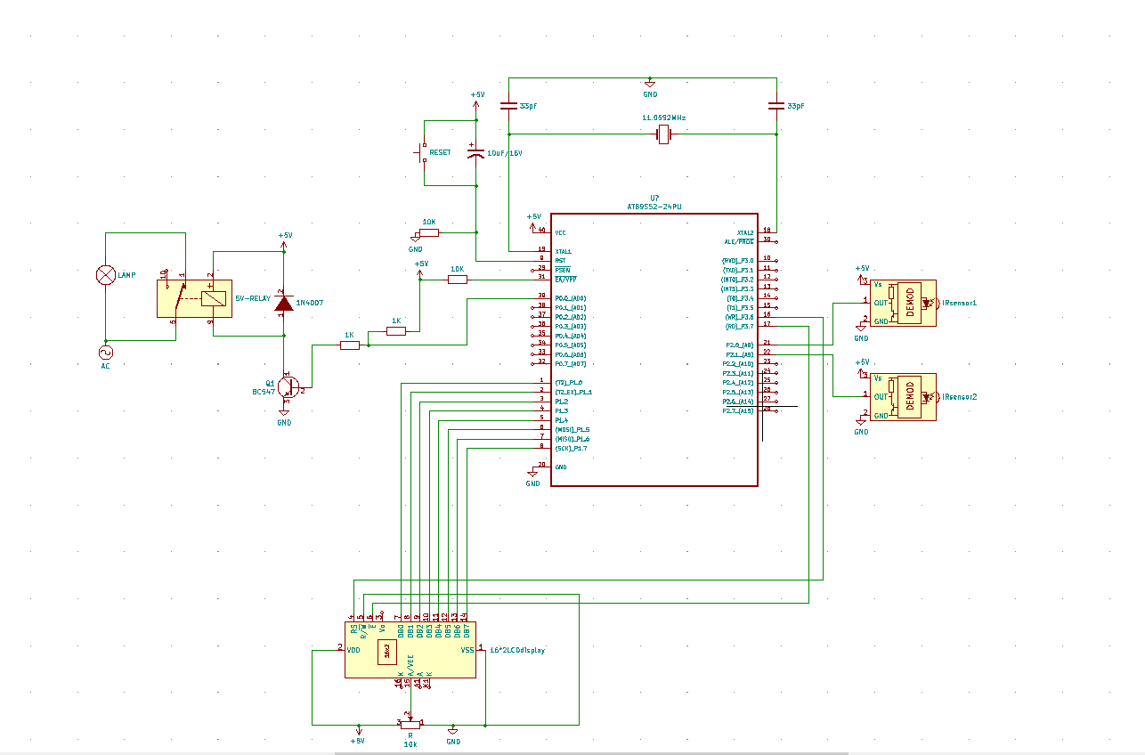  
**FIG 1.1**

**COMPONENTS DESCRIPTION**

* 1. **8051 MICRO-CONTROLLER**

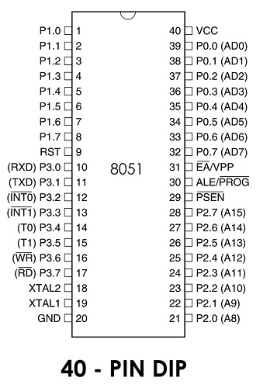

**FIG 1.2**

The Pin Description or Pin Configuration of the 8051 Microcontroller will portray the elements of every pin of the 8051 Microcontroller. Let us presently observe the pin description.

**Pins 1 – 8 (PORT 1):** Pins 1 to 8 are the PORT 1 Pins of 8051. PORT 1 Pins comprises of 8 – bit bidirectional Input/output Port with internal pull – up resistors. In more established 8051 Microcontrollers, PORT 1 doesn't fill any extra need yet only 8 – bit I/O PORT.

In a portion of the more up to date 8051 Microcontrollers, not many PORT 1 Pins have double capacities. P1.0 and P1.1 go about as Timer 2 and Timer 2 Trigger Input separately.

P1.5, P1.6 and P1.7 go about as In-System Programming Pins for example MOSI, MISO and SCK separately.

**Pin 9 (RST):** Pin 9 is the Reset Input Pin. It is a functioning HIGH Pin for example on the off chance that the RST Pin is HIGH for at least two machine cycles, the microcontroller will be reset. During this time, the oscillator must be running.

**Pins 10 – 17 (PORT 3):** Pins 10 to 17 structure the PORT 3 pins of the 8051 Microcontroller. PORT 3 likewise goes about as a bidirectional Input/output PORT with internal pull ups. Moreover, all the PORT 3 Pins have uncommon capacities. The accompanying table gives the subtleties of the extra elements of PORT 3 Pins.

|  |  |  |
| --- | --- | --- |
| **PORT 3 Pin** | **Function** | **Description** |
| P3.0 | RXD | Serial Input |
| P3.1 | TXD | Serial Output |
| P3.2 | INT0 | External Interrupt 0 |
| P3.3 | INT1 | External Interrupt 1 |
| P3.4 | T0 | Timer 0 |
| P3.5 | T1 | Timer 1 |
| P3.6 | WR | External Memory Write |
| P3.7 | RD | External Memory Read |

**Pins 18 and 19:** Pins 18 and 19 for example XTAL 2 and XTAL 1 are the pins for interfacing outside oscillator. By and large, a Quartz Crystal Oscillator is associated here.

**Pin 20 (GND):** Pin 20 is the Ground Pin of the 8051 Microcontroller. It speaks to 0V and is associated with the negative terminal (0V) of the Power Supply.

**Pins 21 – 28 (PORT 2):** These are the PORT 2 Pins of the 8051 Microcontroller. PORT 2 is additionally a Bidirectional Port for example all the PORT 2 pins go about as Input or Output. Furthermore, when outer memory is interfaced, PORT 2 pins go about as the higher request address byte. PORT 2 Pins have internal pull-ups.

**Pin 29 (PSEN):** Pin 29 is the Program Store Enable Pin (PSEN). Utilizing this pins, outside Program Memory can be perused.

**Pin 30 (ALE/PROG):** Pin 30 is the Address Latch Enable Pin. Utilizing this Pins, outside location can be isolated from information (as they are multiplexed by 8051).

During Flash Programming, this pin goes about as program beat input (PROG).

**Pin 31 (EA/VPP):** Pin 31 is the External Access Enable Pin for example permits outer Program Memory. Code from outside program memory can be gotten just if this pin is LOW. For ordinary activities, these pins are pulled HIGH.

During Flash Programming, this Pin gets 12V Programming Enable Voltage (VPP).

**Pins 32 – 39 (PORT 0):** Pins 32 to 39 are PORT 0 Pins. They are likewise bidirectional Input/output Pins yet with no internal pull-ups. Subsequently, we need outer pull-ups so as to utilize PORT 0 pins as I/O PORT.

Notwithstanding going about as I/O PORT, PORT 0 likewise goes about as lower request address/information transport when outside memory is gotten to.

**Pin 40 (VCC):** Pin 40 is the force gracefully pin to which the flexibly voltage is given (+5V).

**8051 MICROCONTROLLER BASIC CIRCUIT**

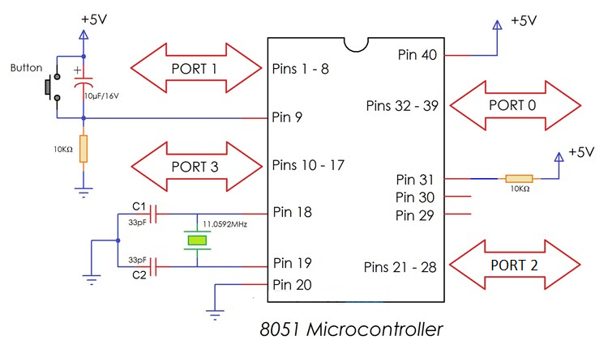

**FIG 1.3**

This fundamental circuit of 8051 microcontroller is the negligible interface required for it to work. The essential circuit incorporates a Reset Circuit, the oscillator circuit and force gracefully. Let us talk about somewhat more profound about this fundamental circuit of 8051 Microcontroller.

First is the force flexibly. Pins 40 and 20 (VCC and GND) of the 8051 Microcontroller are associated with +5V and GND separately.

Next is the Reset Circuit. A rationale HIGH (+5V) on Reset Pin for at least two machine cycles (24 clock cycles) will reset the 8051 Microcontroller. The reset circuit of the 8051 Microcontroller comprises of a capacitor, a resistor and a press catch and this kind of reset circuit gives a Manual Reset Option. In the event that you expel the press button, at that point the reset circuit turns into a Power-On Reset Circuit.

The following piece of the fundamental circuit of the 8051 Microcontroller is the Oscillator Circuit or the Clock Circuit. A Quartz Crystal Oscillator is associated across XTAL1 and XTAL2 pins for example Pins 19 and 18. The capacitors C1 and C2 can be chosen in the scope of 20pF to 40pF.

As referenced in the 8051 Microcontroller Pin Description, PORTS 1, 2 and 3, all have inner force – ups and henceforth can be straightforwardly utilized as Bidirectional I/O Ports. Be that as it may, we have to include outer Pull – ups for PORT 0 Pins so as to utilize it as an I/O Port.

For the most part, a 1KΩ Resistor Pack of 8 Resistors is utilized as a Pull – up for the PORT 0 of the 8051 Microcontroller

**APPLICATIONS OF 8051 MICROCONTROLLER**

1. **Energy Management:** Competent measuring device systems aid in calculating energy consumption in domestic and industrialized applications. These meter systems are prepared competent by integrating microcontrollers.
2. **Touch screens:** A high degree of microcontroller suppliers integrate touch sensing abilities in their designs. Transportable devices such as media players, gaming devices & cell phones are some illustrations of micro-controller integrated with touch sensing screens.
3. **Automobiles:** The microcontroller 8051 discovers broad recognition in supplying automobile solutions. They are extensively utilized in hybrid motor vehicles to control engine variations. Also, works such as cruise power and anti-brake mechanism has created it more capable with the amalgamation of micro-controllers.
4. **Medical Devices:** Handy medicinal gadgets such as glucose & blood pressure monitors bring into play micro-controllers, to put on view the measurements, as a result, offering higher dependability in giving correct medical results.
5. **Medical Devices:** Handy medicinal gadgets such as glucose & blood pressure monitors bring into play micro-controllers, to put on view the measurements, as a result, offering higher dependability in giving correct medical results.

**3.2 IR SENSOR**

Infrared innovation tends to a wide assortment of remote applications. The principle regions are detecting and remote controls. In the electromagnetic range, the infrared bit is partitioned into three locales: close to infrared district, mid infrared area and far infrared area**.**

The frequencies of these regions and their applications are demonstrated as follows.

Close to infrared regions — 700 nm to 1400 nm — IR sensors, fibre optic

Mid infrared regions — 1400 nm to 3000 nm — Heat detecting

Far infrared regions— 3000 nm to 1 mm — Thermal imaging

The recurrence scope of infrared is higher than microwave and lesser than noticeable light. For optical detecting and optical correspondence, photograph optics advancements are utilized in the close to infrared locale as the light is less mind boggling than RF when executed as a wellspring of sign. Optical remote correspondence is finished with IR information transmission for short range applications. An infrared sensor discharges and additionally distinguishes infrared radiation to detect its environmental factors.

The working of any Infrared sensor is administered by three laws: Planck's Radiation law, Stephen – Boltzmann law and Wien's Displacement law.

Planck's law states that” “every object emits radiation at a temperature not equal to 00K”. Stephen – Boltzmann law states that “at all wavelengths, the total energy emitted by a black body is proportional to the fourth power of the absolute temperature”. According to Wien’s Displacement law, “the radiation curve of a black body for different temperatures will reach its peak at a wavelength inversely proportional to the temperature”.

The fundamental idea of an Infrared Sensor which is utilized as Obstacle indicator is to transmit an infrared sign, this infrared sign bobs from the outside of an item and the sign is gotten at the infrared beneficiary.

There are five essential components utilized in a commonplace infrared location framework: an infrared source, a transmission medium, optical part, infrared indicators or recipients and sign handling. Infrared lasers and Infrared LED's of explicit frequency can be utilized as infrared sources. The three fundamental sorts of media utilized for infrared transmission are vacuum, environment and optical strands. Optical segments are utilized to centre the infrared radiation or to confine the otherworldly reaction.

**TYPES OF IR SENSOR**

Infrared sensors can be passive or active. Passive infrared sensors are essentially Infrared detectors. Passive infrared sensors don't utilize any infrared source and distinguishes vitality transmitted by deterrents in the field of view. They are of two sorts: quantum and warm. Warm infrared sensors utilize infrared vitality as the wellspring of warmth and are free of frequency. Thermocouples, pyroelectric detectors and bolometers are the regular sorts of warm infrared detectors.

Quantum type infrared detectors offer higher discovery execution and are quicker than warm kind infrared detectors. The photosensitivity of quantum type detectors is frequency subordinate. Quantum type detectors are additionally characterized into two kinds: characteristic and outward sorts. Inborn sort quantum detectors are photoconductive cells and photovoltaic cells.

Active infrared sensors comprise of two components: infrared source and infrared detector. Infrared sources incorporate a LED or infrared laser diode. Infrared detectors incorporate photodiodes or phototransistors. The vitality radiated by the infrared source is reflected by an item and falls on the infrared detector.

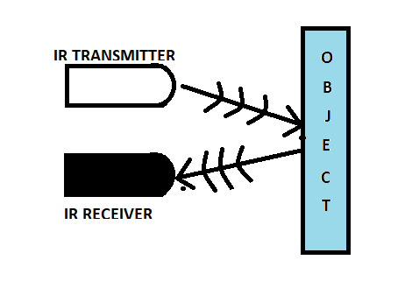

**FIG 1.4**

**IR Transmitter**

Infrared Transmitter is a light emanating diode (LED) which discharges infrared radiations. Subsequently, they are called IR LED's. Despite the fact that an IR LED resembles a typical LED, the radiation produced by it is invisible to the natural eye.

The picture of a typical Infrared LED is shown below.

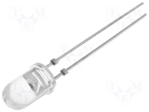

**FIG 1.5**

There are different types of infrared transmitters depending on their wavelengths, output power and response time. A simple infrared transmitter can be constructed using an infrared LED, a current limiting resistor and a power supply.

Infrared transmitters can be balanced to create a specific recurrence of infrared light. The most usually utilized regulation is OOK (ON – OFF – KEYING) adjustment.

When operated at a supply of 5V, the IR transmitter consumes about 3 to 5 mA of current. Infrared transmitters can be balanced to create a specific recurrence of infrared light. The most usually utilized regulation is OOK (ON – OFF – KEYING) adjustment.IR transmitters can be found in a few applications. A few applications require infrared heat and the best infrared source is infrared transmitter. At the point when infrared producers are utilized with Quartz, solar cells can be made.

**IR RECEIVER**

Infrared receivers are likewise called as infrared sensors as they identify the radiation from an IR transmitter. IR receivers come as photodiodes and phototransistors. Infrared Photodiodes are not quite the same as would be expected photograph diodes as they identify just infrared radiation. The image of a run of the mill IR collector or a photodiode is demonstrated as follows.

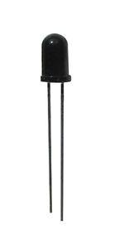

**FIG 1.5**

**PRINCIPLE OF WORKING**

The principle of an IR sensor working as an Object Detection Sensor can be explained using the following figure. An IR sensor consists of an IR LED and an IR Photodiode; together they are called as Photo – Coupler or Opto – Coupler.

When the IR transmitter emits radiation, it reaches the object and some of the radiation reflects back to the IR receiver. Based on the intensity of the reception by the IR receiver, the output of the sensor is defined.

An Infrared or IR Sensor is a basic circuit that is utilized to identify objects (Proximity Sensor) or measure separation (Range Finder).

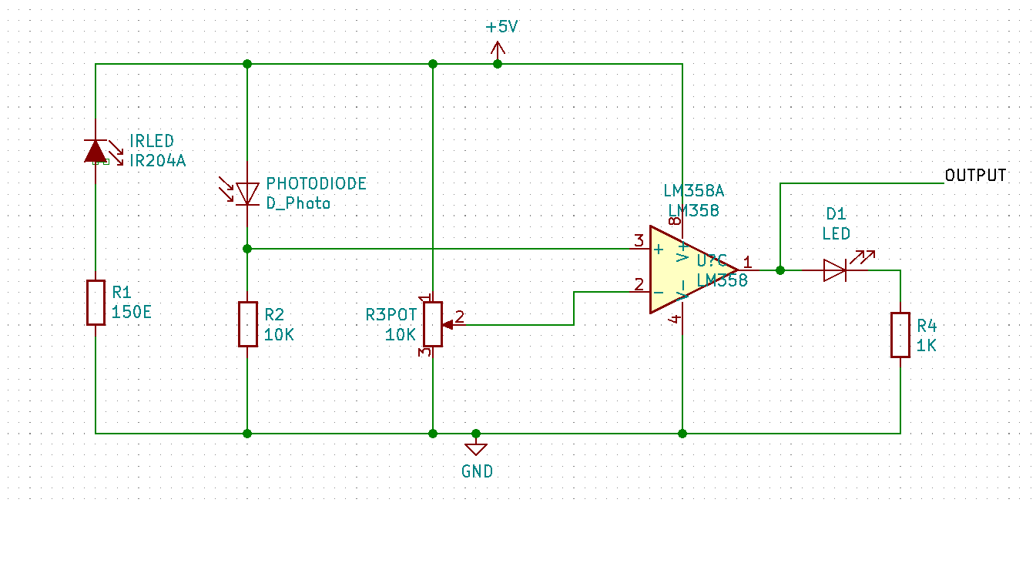

**FIG 1.6**

An Infrared or IR Sensor is a basic circuit that is utilized to identify objects (Proximity Sensor) or measure separation (Range Finder).

An IR Sensor comprises of 3 segments: an IR Transmitter (IR LED), an IR Receiver (like a Photo Diode) and a sign preparing circuit. We have utilized intelligent sort IR sensor modules in this venture. The itemized circuit chart of the module is appeared in the accompanying picture.

**3.3 5v RELAY MODULE**

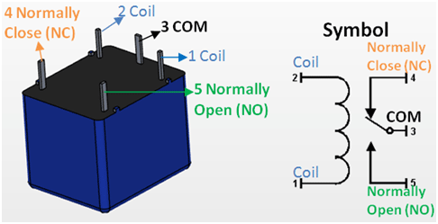

**FIG 1.7**

|  |  |  |
| --- | --- | --- |
| **Pin Number** | **Pin Name** | **Description** |
| 1 | Coil End 1 | Used to trigger (On/Off) the Relay, normally one end is connected to 5V and the other end to ground |
| 2 | Coil End 2 | Used to trigger (On/Off) the Relay, normally one end is connected to 5V and the other end to ground |
| 3 | Common (COM) | Common is connected to one End of the Load that is to be controlled |
| 4 | Normally Close (NC) | The other end of the load is either connected to NO or NC. If connected to NC the load remains connected before trigger |
| 5 | Normally Open (NO) | The other end of the load is either connected to NO or NC. If connected to NO the load remains disconnected before trigger |

**FEATURES OF 5V RELAY MODULE**

* Trigger Voltage (Voltage across coil): 5V DC
* Trigger Current (Nominal current): 70mA
* Maximum AC load current: 10A @ 250/125V AC
* Maximum DC load current: 10A @ 30/28V DC
* Compact 5-pin configuration with plastic moulding
* Operating time: 10msec Release time: 5msec
* Maximum switching: 300 operating/minute (mechanically)

**APPLICATIONS OF 5V RELAY MODULE**

* Commonly used in switching circuits.
* For Home Automation projects to switch AC loads
* To Control (On/Off) Heavy loads at a pre-determined time/condition
* Used in safety circuits to disconnect the load from supply in event of failure
* Used in Automobiles electronics for controlling indicators glass motors etc.

**FEATURES OF 5V RELAY MODULE**

* Good for safe control of higher amperage circuits. In power systems, the lower current can control the higher one.
* 2-channel high voltage system output, meeting the needs of dual channel control.
* Standard interface that can be controlled directly by microcontroller (Arduino, 8051, AVR, PIC, DSP, ARM)]
* Wide range of controllable voltages.
* Being able to control high load current, which can reach 250V, 10A or 125V, 15A
* With a normally-open (NO) contact and a normally-closed (NC) contact.

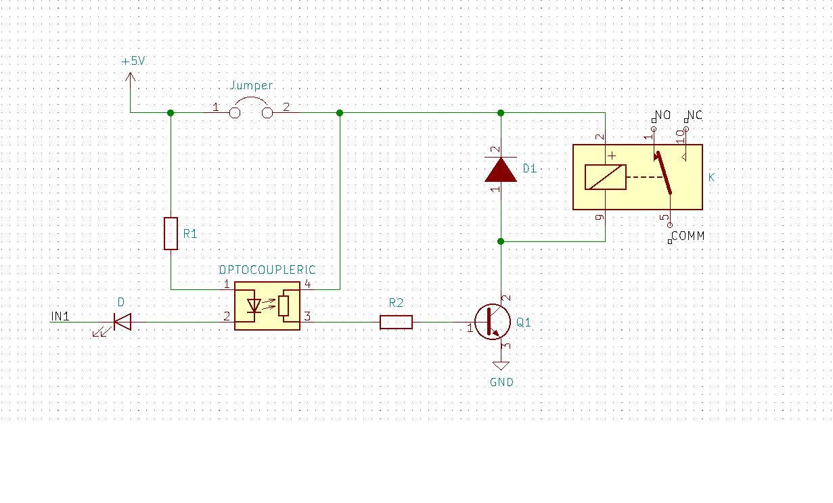

**FIG 1.8**

* A 5V Relay Module is utilized in this project which causes 8051 Microcontroller to work high voltage AC loads like a light. The itemized circuit of the Relay Module is appeared in the accompanying picture. It comprises of a 5V Electromechanical Relay, an Optocoupler IC, transistor, two resistors and two diodes.

**Working of The Project**

In this project, a programmed room lighting framework is created utilizing 8051 microcontroller. The working of the project is clarified here.

The fundamental segment of the project is IR Sensor and we have utilized two of them. The position of the sensors is significant as it will decide the working of the project.

For all intents and purposes, both the sensors must be set on the either side of the entryway or passageway of the room. The sensor put outwardly of the room is named as Sensor 1 and the sensor, which is set within is named Sensor 2.

At the point when an individual attempts to go into the room, Sensor 1 recognizes the individual first and afterward Sensor 2. This activity will show the 8051 Microcontroller that the individual is going into the room.

Thus, the microcontroller will turn on the light and furthermore increases the guest counter to 1. On the off chance that there is more guest, the microcontroller will keep the light turned on and increases the guest counter in like manner.

At the point when an individual attempts to leave the room, Sensor 2 distinguishes the individual first and afterward Sensor 1. This procedure will make the microcontroller to comprehend that an individual is attempting to leave the room and thus, it will decrement the tally of guests. The microcontroller won't turn off the light until the last individual has left the room. As the guests begin leaving the room, the guest check will be decremented and when the last individual leaves the room, the tally be coming 0. During this point, the microcontroller comprehends that there is no one in the room and turns OFF the light.

**CODE FOR THE PROJECT**

#include<reg51.h>

#define lcd P1

sbit rs=P3^6;

sbit e=P3^7;

sbit relay=P0^0;

sbit s1=P2^0;

sbit s2=P2^1;

void delay (int);

void cmd (char);

void display (char);

void init (void);

void string (char *);

void view (int);

int count=0;

int no [10] = {48,49,50,51,52,53,54,55,56,57};

void delay (int d)

{

unsigned char i=0;

for (; d>0; d--)

{ for (i=250; i>0; i--);

for (i=248; i>0; i--);

}

}

void cmd (char c)

{

lcd=c;

rs=0;

e=1;

delay (5);

e=0;

}

void display (char c)

{ lcd=c;

rs=1;

e=1;

delay (5);

e=0;

}

void string (char *p)

{

while(*p)

{

display(*p++);

}

}

void view (int n)

{ cmd(0xc0);

display(no[(n/10) %10]);

display(no[n%10]);

}

void init (void)

{ cmd(0x38);

cmd(0x0c);

cmd(0x01);

cmd(0x80);

}

void main ()

{

init ();

string("counter........");

cmd(0xc0);

view(count);

while (1)

{

if(s1==1)

{

while(s2==0);

if (count! =99)

count=count+1;

while(s2==1);

view(count);

}

else if(s2==1)

{ while(s1==0);

if (count! =0)

count=count-1;

while(s1==1);

view(count);

}

else if(count==1)

relay=0;

else if(count==0)

relay=1;

}

}

**APPLICATIONS**

* Automatic Room Lighting with Bidirectional Visitor Counter can be used to automatically turn on the light in a room when a person enters the room and turn it off when the person leaves the room.
* The project can also be dubbed as a Bidirectional Visitor Counter it is an integral part of the Automatic Room Lighting circuit.
* The project can be modified with LEDs and as the number of persons in the room increases, the number of LEDs turning ON also increases.

**REFERENCES**

**1.ELECTRONICHUB.COM**

**2.** **ELPROCUS.COM**

**3.** **COMPONENTS101.COM**

**4.** **SNAPEDA.COM**